- Write a Terraform script to create a VPC with public and private subnets.
Objective: need to create the VPC along with Public and Private subnets using terraform configuration
Write terraform configuration(main.tf)
provider "aws" {
region = "us-east-1"
}

# VPC
resource "aws_vpc" "main" {
cidr_block = "10.0.0.0/16"

tags = {
Name = "terraform-vpc"
}
}

# Public Subnet
resource "aws_subnet" "public" {
vpc_id = aws_vpc.main.id
cidr_block = "10.0.1.0/24"
availability_zone = "us-east-1a"
map_public_ip_on_launch = true

tags = {
Name = "public-subnet"
}
}

# Private Subnet
resource "aws_subnet" "private" {
vpc_id = aws_vpc.main.id
cidr_block = "10.0.2.0/24"
availability_zone = "us-east-1b"

tags = {
Name = "private-subnet"
}
}
Run terraform

Terraform init
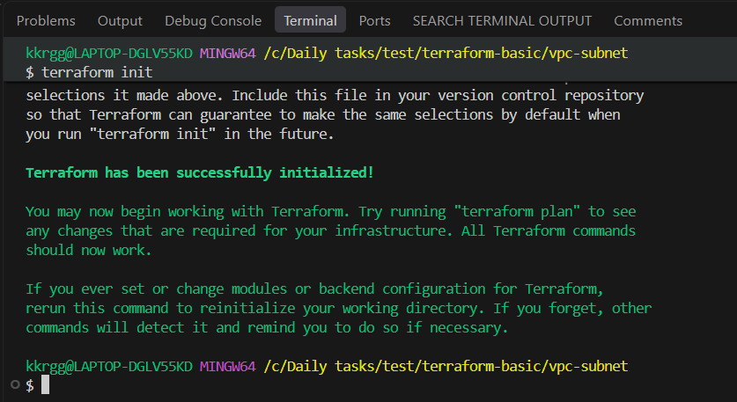

Terraform validate
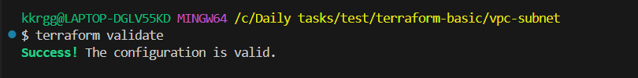
Terraform plan
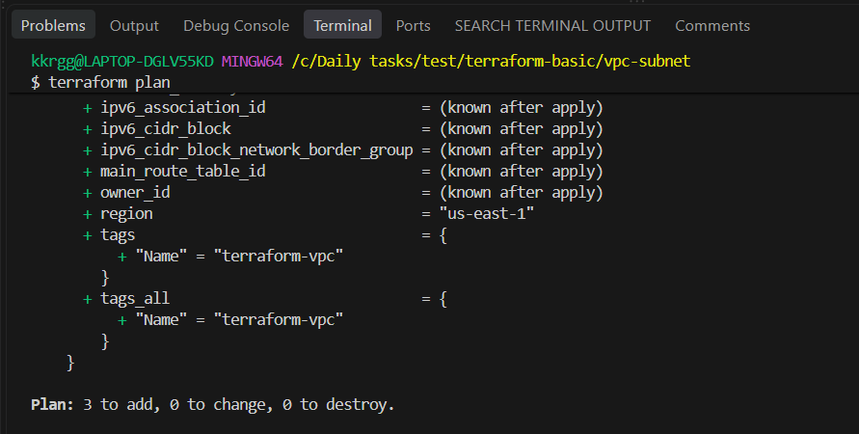
Terraform apply

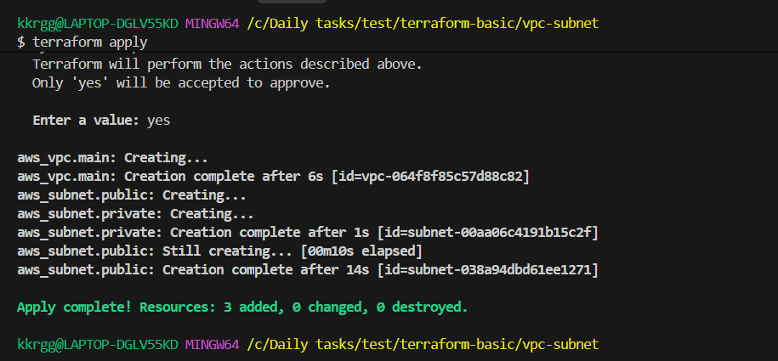

Check in AWS console under vpc service for created VPC and subnets
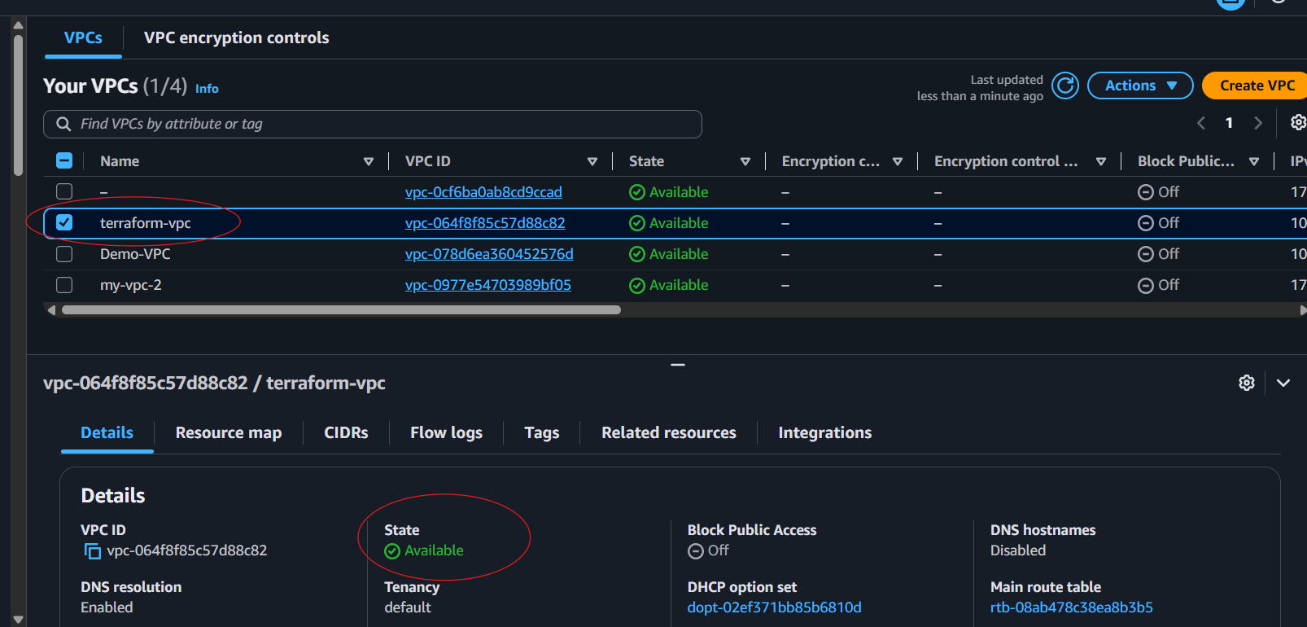

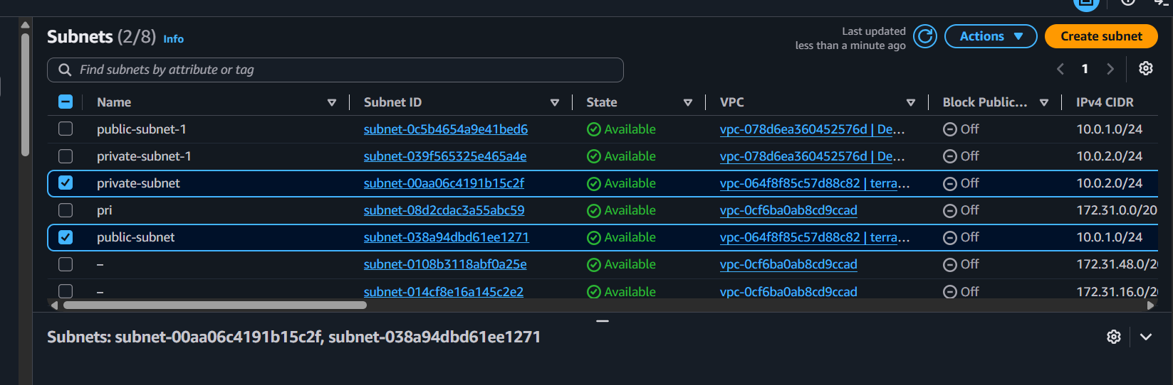

- Write a Terraform script to create an EC2 instance and attach an existing EBS volume.
Objective: To create EC2 instance and attach an existing EBS volume for that instance

Write terraform configuration(main.tf)
provider "aws" {
region = "us-east-1"
}

resource "aws_instance" "server" {
ami = "ami-0b6d9d3d33ba97d99"
instance_type = "t3.micro"

tags = {
Name = "terraform-ec2-ebs"
}
}

resource "aws_volume_attachment" "ebs_attach" {
device_name = "/dev/sdf"
volume_id = "vol-04172b323282511ad"
instance_id = aws_instance.server.id
}

Run terraform
Terraform init
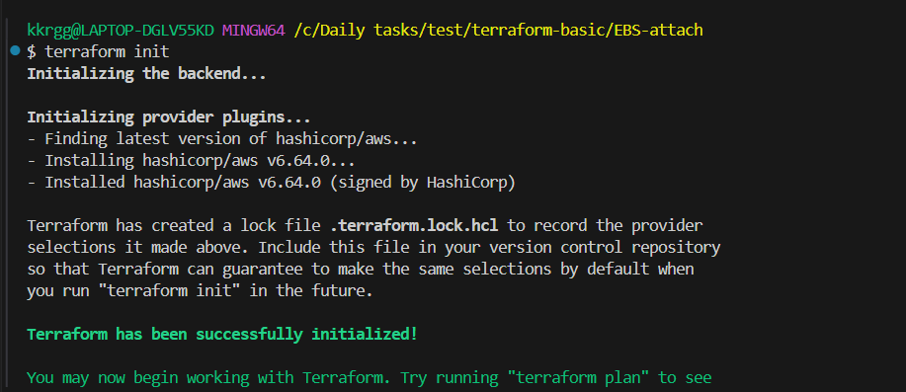

Terraform validate
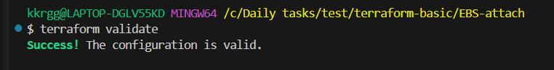

Terraform plan
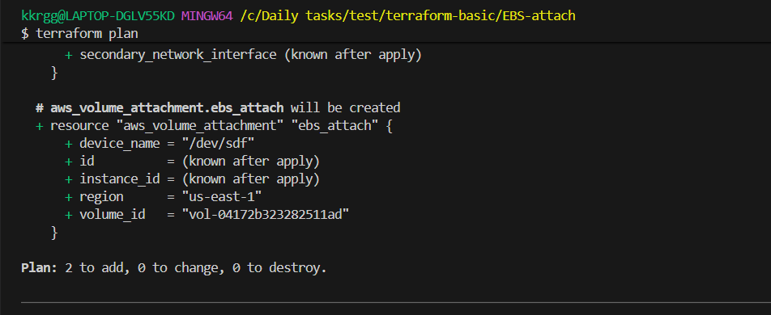

Terraform apply

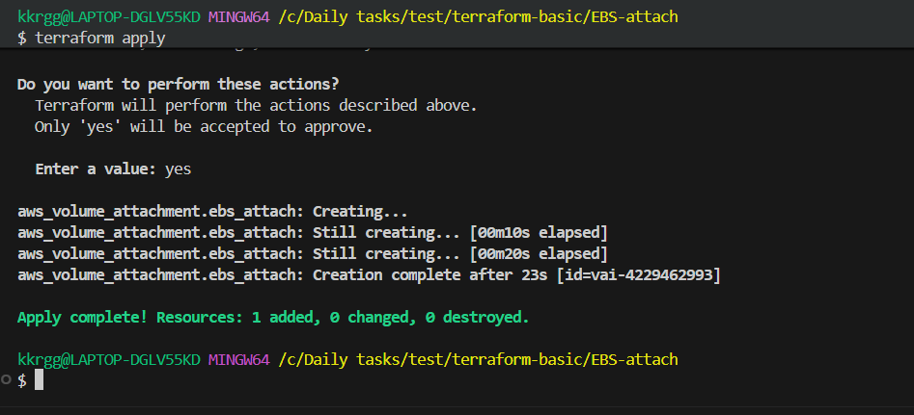

Check on EC2 instance under storage tab
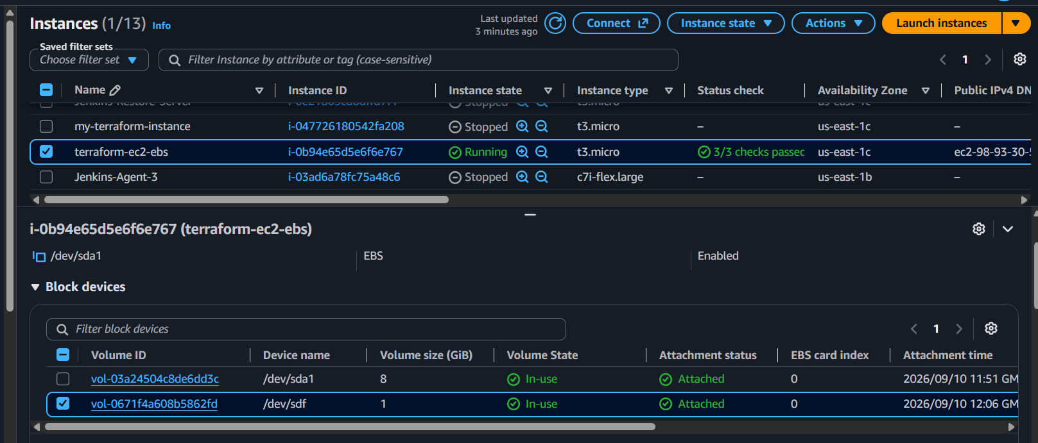
- Write a Terraform script to create an EC2 instance with a Security Group using Terraform.
Objective
Create an EC2 instance in AWS using Terraform and attach a Security Group that allows:
- SSH — port 22
- HTTP — port 80

Architecture
Internet
|
| SSH : 22
| HTTP : 80
v
Security Group
|
v
EC2 Instance

Step 1: Create a project directory
On your Ubuntu/Amazon Linux machine:
mkdir task3-ec2-security-group
cd task3-ec2-security-group
Create the files:
touch main.tf variables.tf outputs.tf
Your structure:
task3-ec2-security-group/
├── main.tf
├── variables.tf
└── outputs.tf

Step 2: Create main.tf
Use this complete configuration:
provider "aws" {
region = "us-east-1"
}

# Get the default VPC
data "aws_vpc" "default" {
default = true
}

# Security Group
resource "aws_security_group" "web_sg" {
name = "terraform-web-sg"
description = "Allow SSH and HTTP"
vpc_id = data.aws_vpc.default.id

# SSH
ingress {
description = "Allow SSH"
from_port = 22
to_port = 22
protocol = "tcp"
cidr_blocks = ["0.0.0.0/0"]
}

# HTTP
ingress {
description = "Allow HTTP"
from_port = 80
to_port = 80
protocol = "tcp"
cidr_blocks = ["0.0.0.0/0"]
}

# Outbound traffic
egress {
from_port = 0
to_port = 0
protocol = "-1"
cidr_blocks = ["0.0.0.0/0"]
}

tags = {
Name = "terraform-web-sg"
}
}

# EC2 Instance
resource "aws_instance" "web" {
ami = var.ami
instance_type = var.instance_type

vpc_security_group_ids = [
aws_security_group.web_sg.id
]

tags = {
Name = "terraform-web-server"
}
}

Important part
This connects the Security Group to the EC2:
vpc_security_group_ids = [
aws_security_group.web_sg.id
]
Terraform understands that the Security Group must exist before it attaches it to the EC2.

Step 3: Create variables.tf
variable "ami" {
description = "AMI ID for EC2"
type = string
}

variable "instance_type" {
description = "EC2 instance type"
type = string
default = "t3.micro"
}

Step 4: Create terraform.tfvars
Create this file:
vi terraform.tfvars
Add your valid us-east-1 AMI ID:
ami = "ami-xxxxxxxxxxxxxxxxx"
instance_type = "t3.micro"
Replace:
ami-xxxxxxxxxxxxxxxxx
with an actual AMI available in us-east-1.

Step 5: Create outputs.tf
output "instance_id" {
description = "EC2 instance ID"
value = aws_instance.web.id
}

output "public_ip" {
description = "EC2 public IP"
value = aws_instance.web.public_ip
}

output "security_group_id" {
description = "Security Group ID"
value = aws_security_group.web_sg.id
}

Step 6: Initialize Terraform
Run:
terraform init
Expected:
Terraform has been successfully initialized!
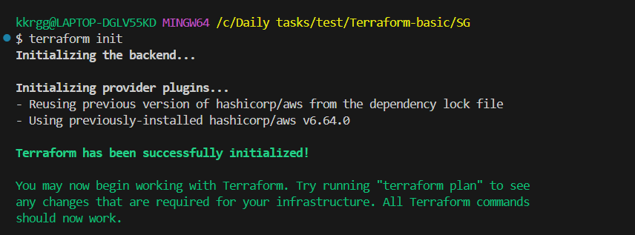

Step 7: Validate
terraform validate
Expected:
Success! The configuration is valid.
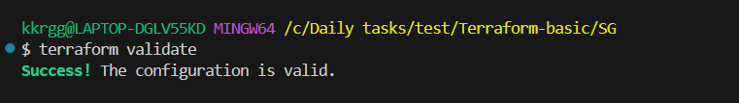

Step 8: Format
terraform fmt
This formats the Terraform files.
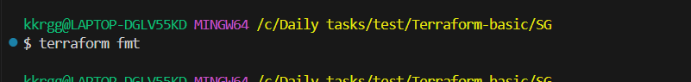

Step 9: Run Terraform Plan
terraform plan
You should see something similar to:
Plan: 2 to add, 0 to change, 0 to destroy.
Why 2?
1 Security Group
1 EC2 Instance
----------------
2 resources

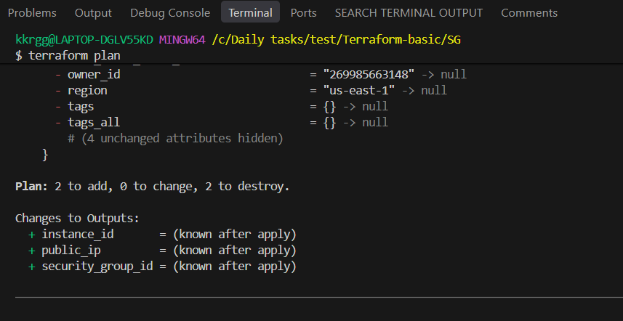

Step 10: Apply
terraform apply
Terraform asks:
Do you want to perform these actions?
Enter a value:
Enter:
yes
Expected:
Apply complete! Resources: 2 added, 0 changed, 0 destroyed.
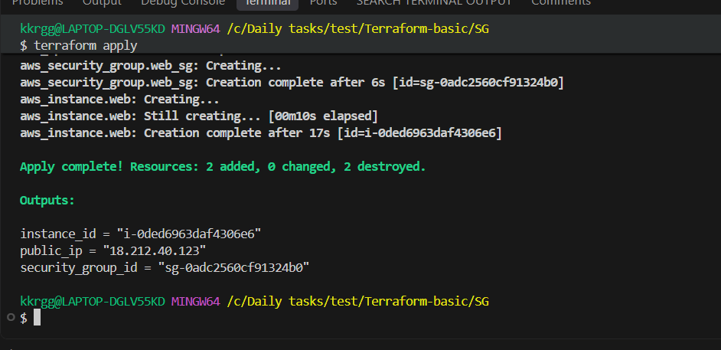

Step 11: Check outputs
terraform output
Example:
instance_id = "i-0123456789abcdef0"
public_ip = "54.xx.xx.xx"
security_group_id = "sg-0123456789abcdef0"
You can also run:
terraform output public_ip
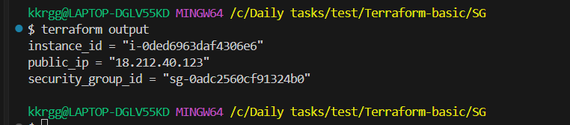

Step 12: Verify in AWS
Go to:
AWS Console → EC2 → Instances
You should see:
terraform-web-server
Then:
EC2 → Security Groups
You should see:
terraform-web-sg
Inbound rules:
Type Port
SSH 22
HTTP 80

Step 13: Verify Terraform state
Run:
ls
You should now have:
main.tf
variables.tf
outputs.tf
terraform.tfvars
terraform.tfstate
terraform.tfstate.backup
.terraform/
.terraform.lock.hcl
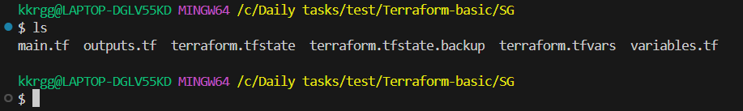

- Write a Terraform script to create an Application Load Balancer with target groups and EC2 instances.

Objective
Create the following using Terraform:
- VPC
- Public subnets in two Availability Zones
- Security Groups
- Two EC2 instances
- Application Load Balancer
- Target Group
- ALB Listener
- Register both EC2 instances with the Target Group

Architecture
Internet
|
|
Application LB
Port 80
|
Target Group
Port 80
/ \
/ \
EC2 Instance 1 EC2 Instance 2
us-east-1a us-east-1b

Step 1: Create project directory
mkdir task4-alb
cd task4-alb
Create files:
touch main.tf variables.tf terraform.tfvars outputs.tf
Structure:
task4-alb/
├── main.tf
├── variables.tf
├── terraform.tfvars
└── outputs.tf

Step 2: Create variables.tf
variable "ami" {
description = "AMI ID for EC2 instances"
type = string
}

variable "instance_type" {
description = "EC2 instance type"
type = string
default = "t3.micro"
}

Step 3: Create terraform.tfvars
Use a valid Amazon Linux AMI from us-east-1.
ami = "ami-xxxxxxxxxxxxxxxxx"
instance_type = "t3.micro"
Replace:
ami-xxxxxxxxxxxxxxxxx
with the AMI ID you are using in your previous AWS labs.

Step 4: Create main.tf
Here is the complete Terraform code.
provider "aws" {
region = "us-east-1"
}

# --------------------------------------------------
# VPC
# --------------------------------------------------

resource "aws_vpc" "main" {
cidr_block = "10.0.0.0/16"

tags = {
Name = "task4-vpc"
}
}

# --------------------------------------------------
# Internet Gateway
# --------------------------------------------------

resource "aws_internet_gateway" "igw" {
vpc_id = aws_vpc.main.id

tags = {
Name = "task4-igw"
}
}

# --------------------------------------------------
# Public Subnet 1
# --------------------------------------------------

resource "aws_subnet" "public_1" {
vpc_id = aws_vpc.main.id
cidr_block = "10.0.1.0/24"
availability_zone = "us-east-1a"
map_public_ip_on_launch = true

tags = {
Name = "task4-public-subnet-1"
}
}

# --------------------------------------------------
# Public Subnet 2
# --------------------------------------------------

resource "aws_subnet" "public_2" {
vpc_id = aws_vpc.main.id
cidr_block = "10.0.2.0/24"
availability_zone = "us-east-1b"
map_public_ip_on_launch = true

tags = {
Name = "task4-public-subnet-2"
}
}

# --------------------------------------------------
# Route Table
# --------------------------------------------------

resource "aws_route_table" "public" {
vpc_id = aws_vpc.main.id

route {
cidr_block = "0.0.0.0/0"
gateway_id = aws_internet_gateway.igw.id
}

tags = {
Name = "task4-public-route-table"
}
}

# --------------------------------------------------
# Route Table Association - Subnet 1
# --------------------------------------------------

resource "aws_route_table_association" "public_1" {
subnet_id = aws_subnet.public_1.id
route_table_id = aws_route_table.public.id
}

# --------------------------------------------------
# Route Table Association - Subnet 2
# --------------------------------------------------

resource "aws_route_table_association" "public_2" {
subnet_id = aws_subnet.public_2.id
route_table_id = aws_route_table.public.id
}

# --------------------------------------------------
# Security Group for ALB
# --------------------------------------------------

resource "aws_security_group" "alb_sg" {
name = "task4-alb-sg"
description = "Allow HTTP traffic to ALB"
vpc_id = aws_vpc.main.id

ingress {
description = "Allow HTTP"
from_port = 80
to_port = 80
protocol = "tcp"
cidr_blocks = ["0.0.0.0/0"]
}

egress {
from_port = 0
to_port = 0
protocol = "-1"
cidr_blocks = ["0.0.0.0/0"]
}

tags = {
Name = "task4-alb-sg"
}
}

# --------------------------------------------------
# Security Group for EC2
# --------------------------------------------------

resource "aws_security_group" "web_sg" {
name = "task4-web-sg"
description = "Allow HTTP traffic from ALB and SSH"
vpc_id = aws_vpc.main.id

# HTTP from ALB
ingress {
description = "HTTP from ALB"
from_port = 80
to_port = 80
protocol = "tcp"
security_groups = [aws_security_group.alb_sg.id]
}

# SSH
ingress {
description = "SSH"
from_port = 22
to_port = 22
protocol = "tcp"
cidr_blocks = ["0.0.0.0/0"]
}

egress {
from_port = 0
to_port = 0
protocol = "-1"
cidr_blocks = ["0.0.0.0/0"]
}

tags = {
Name = "task4-web-sg"
}
}

# --------------------------------------------------
# EC2 Instance 1
# --------------------------------------------------

resource "aws_instance" "web1" {
ami = var.ami
instance_type = var.instance_type

subnet_id = aws_subnet.public_1.id

vpc_security_group_ids = [
aws_security_group.web_sg.id
]

user_data = <<-EOF
#!/bin/bash
dnf install -y nginx
systemctl enable nginx
systemctl start nginx
echo "Hello from Web Server 1" > /usr/share/nginx/html/index.html
EOF

tags = {
Name = "task4-web1"
}
}

# --------------------------------------------------
# EC2 Instance 2
# --------------------------------------------------

resource "aws_instance" "web2" {
ami = var.ami
instance_type = var.instance_type

subnet_id = aws_subnet.public_2.id

vpc_security_group_ids = [
aws_security_group.web_sg.id
]

user_data = <<-EOF
#!/bin/bash
dnf install -y nginx
systemctl enable nginx
systemctl start nginx
echo "Hello from Web Server 2" > /usr/share/nginx/html/index.html
EOF

tags = {
Name = "task4-web2"
}
}

# --------------------------------------------------
# Application Load Balancer
# --------------------------------------------------

resource "aws_lb" "app_lb" {
name = "task4-alb"
internal = false
load_balancer_type = "application"

security_groups = [
aws_security_group.alb_sg.id
]

subnets = [
aws_subnet.public_1.id,
aws_subnet.public_2.id
]

tags = {
Name = "task4-alb"
}
}

# --------------------------------------------------
# Target Group
# --------------------------------------------------

resource "aws_lb_target_group" "app_tg" {
name = "task4-target-group"
port = 80
protocol = "HTTP"
vpc_id = aws_vpc.main.id

health_check {
enabled = true
path = "/"
protocol = "HTTP"
port = "traffic-port"
healthy_threshold = 2
unhealthy_threshold = 2
timeout = 5
interval = 30
matcher = "200"
}

tags = {
Name = "task4-target-group"
}
}

# --------------------------------------------------
# Register EC2 Instance 1
# --------------------------------------------------

resource "aws_lb_target_group_attachment" "web1" {
target_group_arn = aws_lb_target_group.app_tg.arn
target_id = aws_instance.web1.id
port = 80
}

# --------------------------------------------------
# Register EC2 Instance 2
# --------------------------------------------------

resource "aws_lb_target_group_attachment" "web2" {
target_group_arn = aws_lb_target_group.app_tg.arn
target_id = aws_instance.web2.id
port = 80
}

# --------------------------------------------------
# ALB Listener
# --------------------------------------------------

resource "aws_lb_listener" "http" {
load_balancer_arn = aws_lb.app_lb.arn
port = 80
protocol = "HTTP"

default_action {
type = "forward"
target_group_arn = aws_lb_target_group.app_tg.arn
}
}

Step 5: Create outputs.tf
output "alb_dns_name" {
description = "DNS name of the Application Load Balancer"
value = aws_lb.app_lb.dns_name
}

output "web1_public_ip" {
description = "Public IP of Web Server 1"
value = aws_instance.web1.public_ip
}

output "web2_public_ip" {
description = "Public IP of Web Server 2"
value = aws_instance.web2.public_ip
}

output "target_group_arn" {
description = "Target Group ARN"
value = aws_lb_target_group.app_tg.arn
}

Step 6: Initialize Terraform
terraform init
Expected:
Terraform has been successfully initialized!
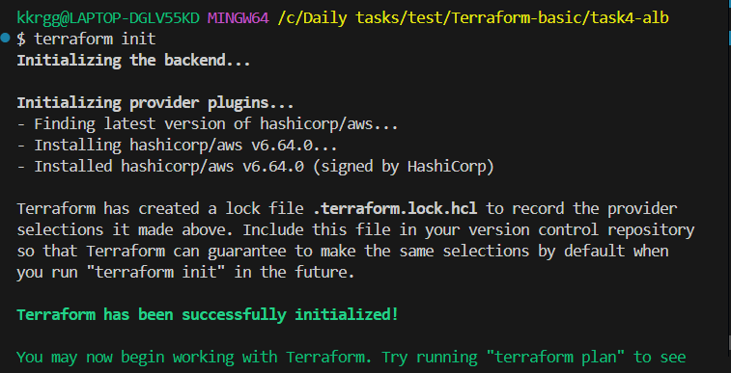

Step 7: Validate
terraform validate
Expected:
Success! The configuration is valid.
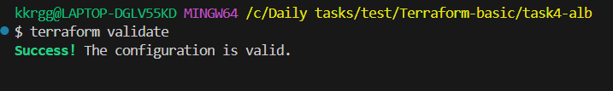

Step 8: Format
terraform fmt

Step 9: Run Plan
terraform plan
You should see approximately:
Plan: 13 to add, 0 to change, 0 to destroy.
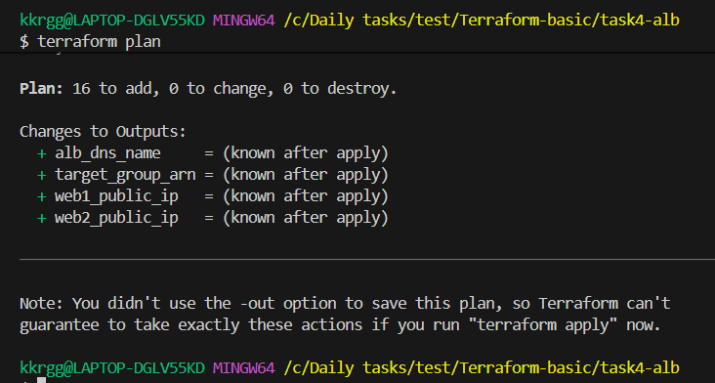
The exact number can vary if you modify the configuration.
Resources include:
VPC
Internet Gateway
2 Subnets
Route Table
2 Route Table Associations
2 Security Groups
2 EC2 Instances
ALB
Target Group
2 Target Attachments
ALB Listener

Step 10: Apply
terraform apply
Enter:
yes
Wait for Terraform to finish.
You should get:
Apply complete! Resources: ... added, 0 changed, 0 destroyed.
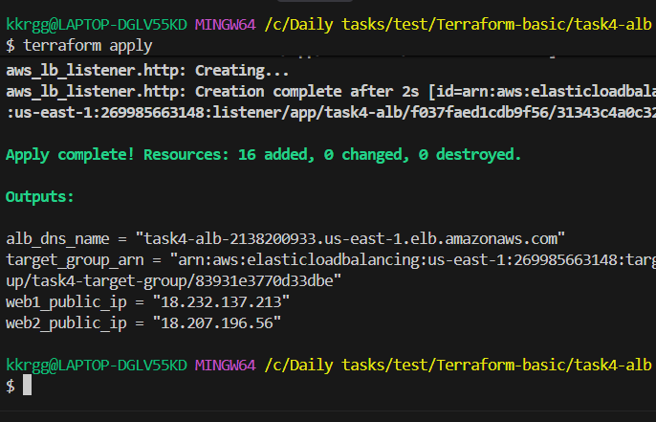

Step 11: Get the ALB DNS name
Run:
terraform output alb_dns_name
Example:
"task4-alb-123456789.us-east-1.elb.amazonaws.com"
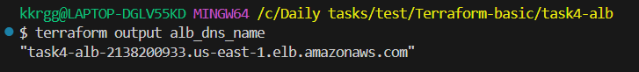
Copy the DNS name and open:
http://task4-alb-123456789.us-east-1.elb.amazonaws.com
You should see either:
Hello from Web Server 1
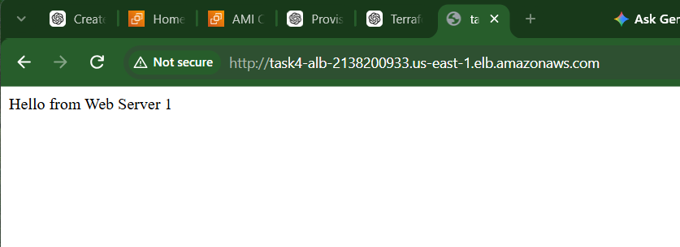
or:
Hello from Web Server 2
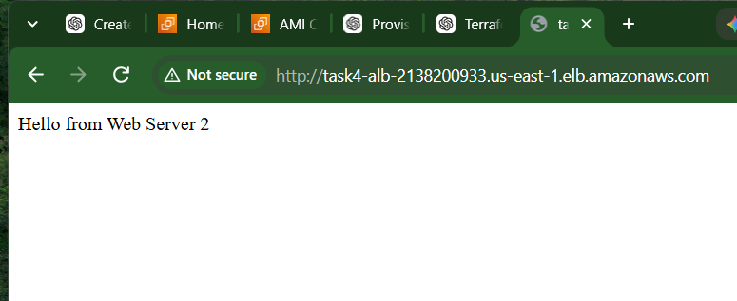
Refresh several times. The ALB distributes requests between the healthy targets.

Step 12: Verify Target Group
Go to:
AWS Console → EC2 → Target Groups
Select:
task4-target-group
Go to:
Targets
You should see:
Instance Port Health
------------------------------------------------
task4-web1 80 Healthy
task4-web2 80 Healthy
If they show Healthy, our ALB setup is working.
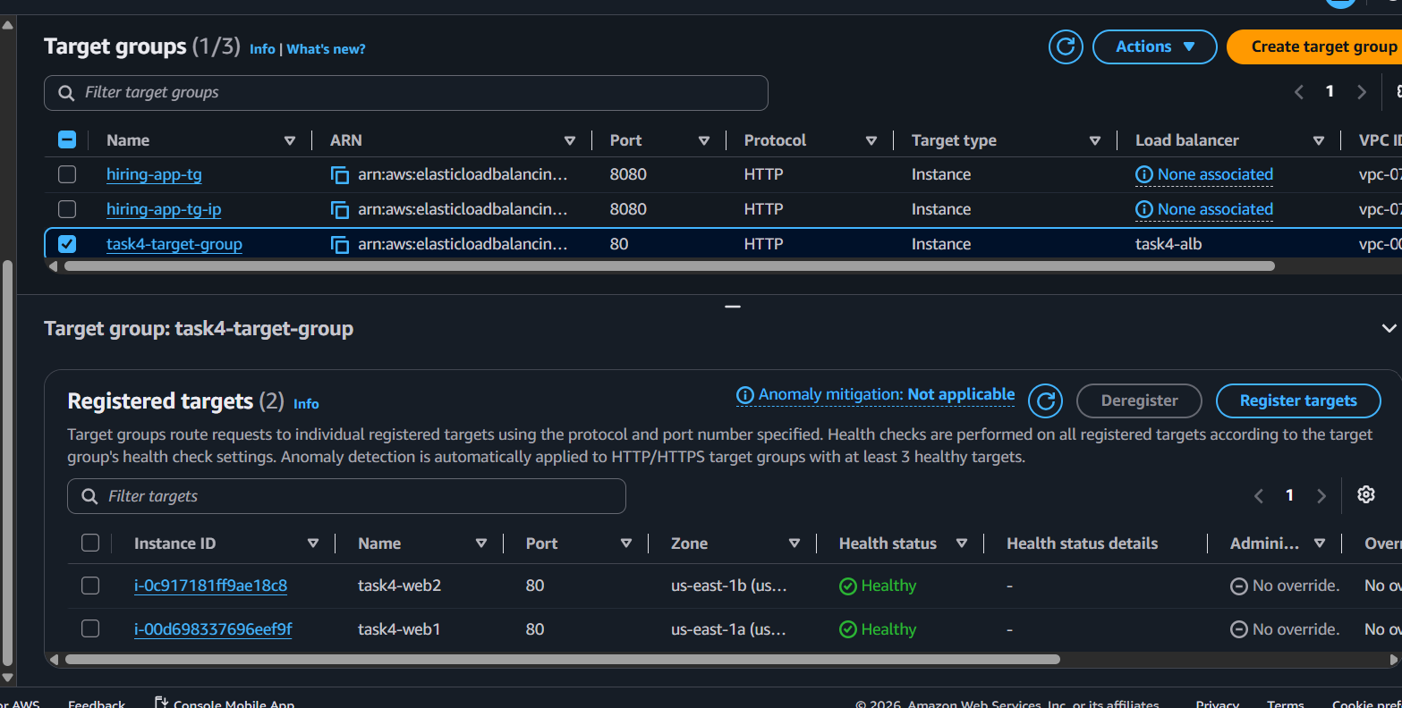

Step 13: Understand the traffic flow
This is the most important part of Task 4.
Internet
|
| HTTP :80
v
+---------------+
| ALB |
+---------------+
|
v
+---------------+
| Target Group |
+---------------+
/ \
/ \
v v
+-----------+ +-----------+
| EC2 1 | | EC2 2 |
| :80 | | :80 |
+-----------+ +-----------+
Security Groups:
Internet
|
| :80
v
ALB Security Group
|
| :80
v
EC2 Security Group
Notice that the EC2 Security Group allows HTTP from the ALB Security Group, rather than from the whole internet:
security_groups = [aws_security_group.alb_sg.id]
That's a better architecture.

5. Write a Terraform script to create an Auto Scaling Group with a Launch Template

Objective
Create an Auto Scaling Group (ASG) using Terraform with a Launch Template.
The setup will:
- Create a VPC
- Create two public subnets in different Availability Zones
- Create a Security Group
- Create a Launch Template
- Create an Auto Scaling Group
- Launch EC2 instances automatically
- Maintain the desired number of instances

Architecture
VPC
|
+------------+------------+
| |
Public Subnet 1 Public Subnet 2
us-east-1a us-east-1b
| |
+------------+------------+
|
Auto Scaling Group
|
Launch Template
|
+--------+--------+
| |
EC2-1 EC2-2

Step 1: Create the project
mkdir task5-asg
cd task5-asg
Create the files:
touch main.tf variables.tf terraform.tfvars outputs.tf
Directory:
task5-asg/
├── main.tf
├── variables.tf
├── terraform.tfvars
└── outputs.tf

Step 2: Create variables.tf
variable "ami" {
description = "AMI ID for EC2 instances"
type = string
}

variable "instance_type" {
description = "EC2 instance type"
type = string
default = "t3.micro"
}

variable "desired_capacity" {
description = "Desired number of EC2 instances"
type = number
default = 2
}

variable "min_size" {
description = "Minimum number of EC2 instances"
type = number
default = 1
}

variable "max_size" {
description = "Maximum number of EC2 instances"
type = number
default = 3
}

Step 3: Create terraform.tfvars
Use the same valid us-east-1 AMI that you used in Task 4.
ami = "ami-xxxxxxxxxxxxxxxxx"
instance_type = "t3.micro"
desired_capacity = 2
min_size = 1
max_size = 3
Replace:
ami-xxxxxxxxxxxxxxxxx
with your actual AMI ID.

Step 4: Create main.tf
Use this complete configuration:
provider "aws" {
region = "us-east-1"
}

# --------------------------------------------------
# VPC
# --------------------------------------------------

resource "aws_vpc" "main" {
cidr_block = "10.0.0.0/16"

tags = {
Name = "task5-vpc"
}
}

# --------------------------------------------------
# Internet Gateway
# --------------------------------------------------

resource "aws_internet_gateway" "igw" {
vpc_id = aws_vpc.main.id

tags = {
Name = "task5-igw"
}
}

# --------------------------------------------------
# Public Subnet 1
# --------------------------------------------------

resource "aws_subnet" "public_1" {
vpc_id = aws_vpc.main.id
cidr_block = "10.0.1.0/24"
availability_zone = "us-east-1a"
map_public_ip_on_launch = true

tags = {
Name = "task5-public-subnet-1"
}
}

# --------------------------------------------------
# Public Subnet 2
# --------------------------------------------------

resource "aws_subnet" "public_2" {
vpc_id = aws_vpc.main.id
cidr_block = "10.0.2.0/24"
availability_zone = "us-east-1b"
map_public_ip_on_launch = true

tags = {
Name = "task5-public-subnet-2"
}
}

# --------------------------------------------------
# Public Route Table
# --------------------------------------------------

resource "aws_route_table" "public" {
vpc_id = aws_vpc.main.id

route {
cidr_block = "0.0.0.0/0"
gateway_id = aws_internet_gateway.igw.id
}

tags = {
Name = "task5-public-route-table"
}
}

# --------------------------------------------------
# Route Table Association - Subnet 1
# --------------------------------------------------

resource "aws_route_table_association" "public_1" {
subnet_id = aws_subnet.public_1.id
route_table_id = aws_route_table.public.id
}

# --------------------------------------------------
# Route Table Association - Subnet 2
# --------------------------------------------------

resource "aws_route_table_association" "public_2" {
subnet_id = aws_subnet.public_2.id
route_table_id = aws_route_table.public.id
}

# --------------------------------------------------
# Security Group
# --------------------------------------------------

resource "aws_security_group" "web_sg" {
name = "task5-web-sg"
description = "Allow HTTP and SSH"
vpc_id = aws_vpc.main.id

# HTTP
ingress {
description = "HTTP"
from_port = 80
to_port = 80
protocol = "tcp"
cidr_blocks = ["0.0.0.0/0"]
}

# SSH
ingress {
description = "SSH"
from_port = 22
to_port = 22
protocol = "tcp"
cidr_blocks = ["0.0.0.0/0"]
}

# Outbound
egress {
from_port = 0
to_port = 0
protocol = "-1"
cidr_blocks = ["0.0.0.0/0"]
}

tags = {
Name = "task5-web-sg"
}
}

# --------------------------------------------------
# Launch Template
# --------------------------------------------------

resource "aws_launch_template" "web" {
name_prefix = "task5-web-"
image_id = var.ami
instance_type = var.instance_type

vpc_security_group_ids = [
aws_security_group.web_sg.id
]

user_data = base64encode(<<-EOF
#!/bin/bash

dnf install -y nginx

systemctl enable nginx
systemctl start nginx

INSTANCE_ID=$(curl -s http://169.254.169.254/latest/meta-data/instance-id)

echo "<h1>Hello from Auto Scaling Group</h1>" > /usr/share/nginx/html/index.html
echo "<p>Instance ID: $INSTANCE_ID</p>" >> /usr/share/nginx/html/index.html
EOF
)

tag_specifications {
resource_type = "instance"

tags = {
Name = "task5-asg-instance"
}
}

tags = {
Name = "task5-launch-template"
}
}

# --------------------------------------------------
# Auto Scaling Group
# --------------------------------------------------

resource "aws_autoscaling_group" "web" {
name = "task5-asg"

min_size = var.min_size
max_size = var.max_size
desired_capacity = var.desired_capacity

vpc_zone_identifier = [
aws_subnet.public_1.id,
aws_subnet.public_2.id
]

launch_template {
id = aws_launch_template.web.id
version = "$Latest"
}

health_check_type = "EC2"
health_check_grace_period = 120

tag {
key = "Name"
value = "task5-asg-instance"
propagate_at_launch = true
}
}

Step 5: Create outputs.tf
output "asg_name" {
description = "Auto Scaling Group name"
value = aws_autoscaling_group.web.name
}

output "launch_template_id" {
description = "Launch Template ID"
value = aws_launch_template.web.id
}

output "vpc_id" {
description = "VPC ID"
value = aws_vpc.main.id
}

output "subnet_1_id" {
description = "Public subnet 1 ID"
value = aws_subnet.public_1.id
}

output "subnet_2_id" {
description = "Public subnet 2 ID"
value = aws_subnet.public_2.id
}

Step 6: Initialize Terraform
terraform init
Expected:
Terraform has been successfully initialized!
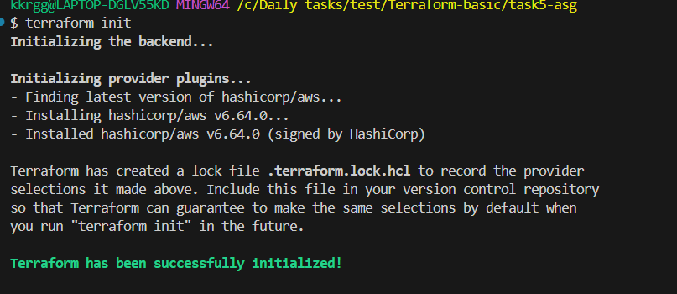

Step 7: Validate
terraform validate
Expected:
Success! The configuration is valid.
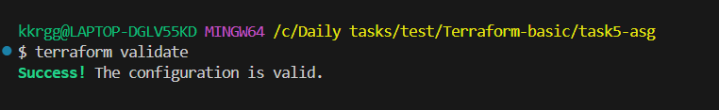

Step 8: Format
terraform fmt

Step 9: Run Terraform Plan
terraform plan
Terraform should show resources being created.
The important resources are:
VPC
Internet Gateway
2 Subnets
Route Table
2 Route Associations
Security Group
Launch Template
Auto Scaling Group
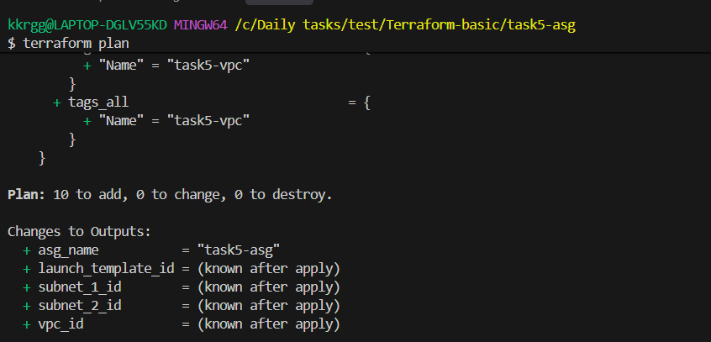

Step 10: Apply
terraform apply
Enter:
yes
After successful completion:
Apply complete! Resources: ... added, 0 changed, 0 destroyed.
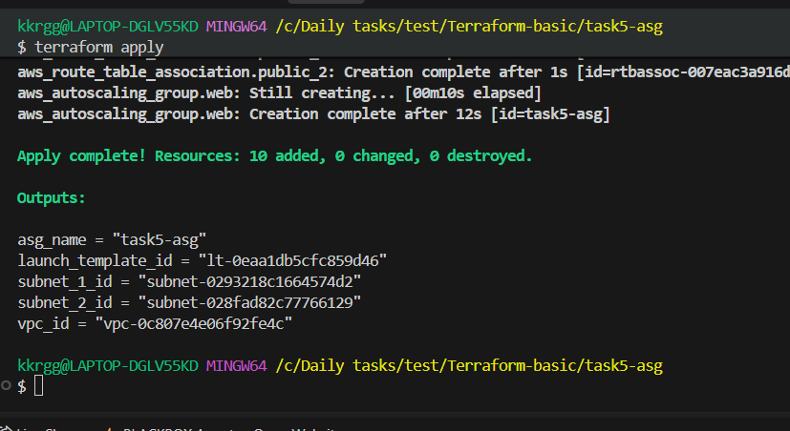

Step 11: Check the ASG
Run:
terraform output
You should see something similar to:
asg_name = "task5-asg"
launch_template_id = "lt-0123456789abcdef"
subnet_1_id = "subnet-..."
subnet_2_id = "subnet-..."
vpc_id = "vpc-..."

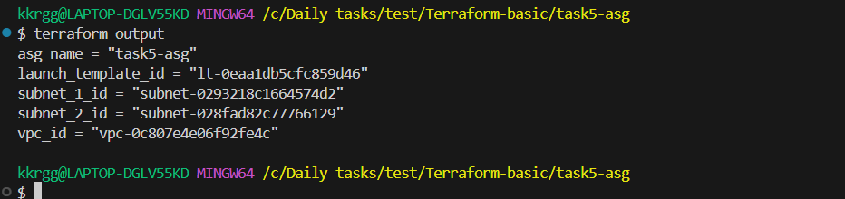

Step 12: Verify in AWS Console
Go to:
AWS Console → EC2 → Auto Scaling Groups
You should see:
task5-asg
Check:
Desired capacity: 2
Minimum capacity: 1
Maximum capacity: 3
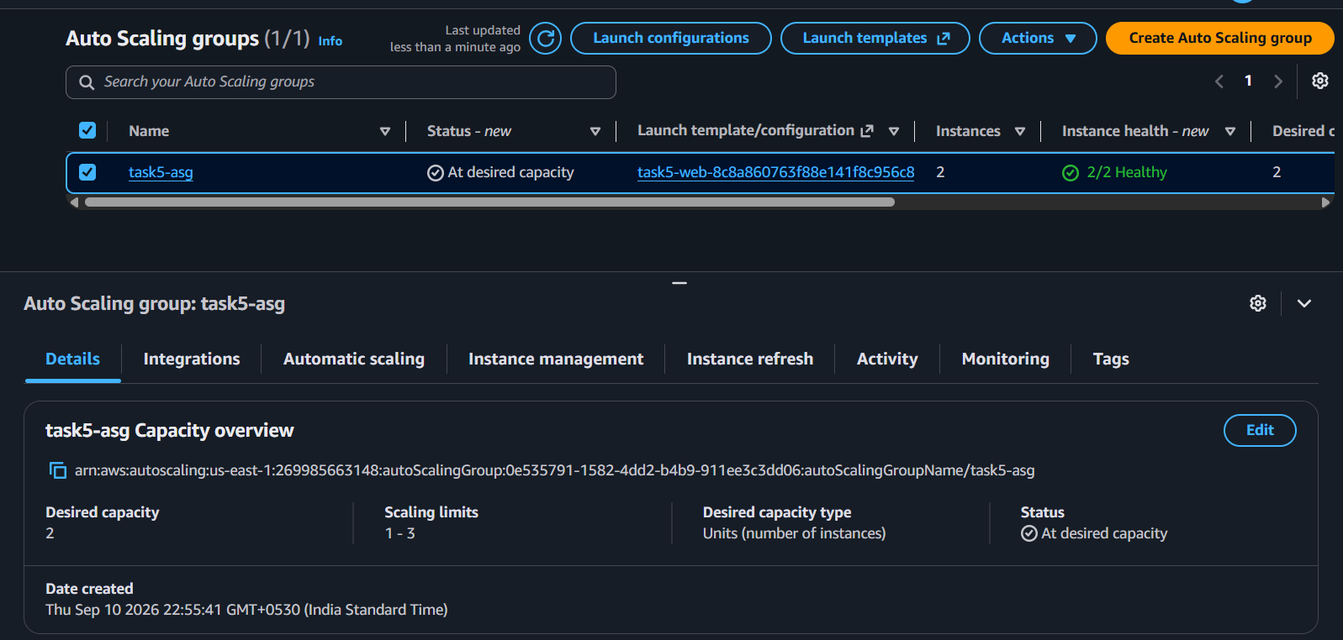
Then go to:
EC2 → Instances
You should see 2 EC2 instances created automatically.
They should be distributed between:
us-east-1a
us-east-1b
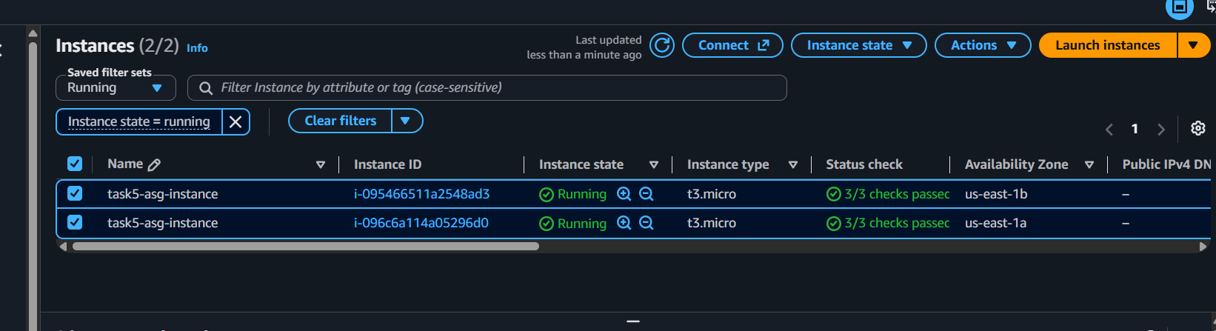

Step 13: Understand Launch Template
The Launch Template defines how an EC2 instance should be launched.
In our configuration:
resource "aws_launch_template" "web" {
image_id = var.ami
instance_type = var.instance_type
}
It specifies:
AMI
Instance Type
Security Group
User Data
Tags
6. Write a Terraform script to create multiple resources using for_each with a map variable.

Objective
In this task, we will use Terraform's for_each meta-argument with a map variable to create multiple EC2 instances with different configurations.
We will create:
web-server → t3.micro
app-server → t3.micro
dev-server → t3.small
The important concept is that one Terraform resource block creates multiple EC2 instances.

Step 1: Create the project
mkdir task6-for-each
cd task6-for-each
Create the files:
touch main.tf variables.tf terraform.tfvars outputs.tf
Directory:
task6-for-each/
├── main.tf
├── variables.tf
├── terraform.tfvars
└── outputs.tf

Step 2: Create variables.tf
We will define a map:
variable "instances" {
description = "EC2 instances to create"
type = map(string)
}
Complete file:
variable "instances" {
description = "EC2 instances to create"
type = map(string)
}

variable "ami" {
description = "AMI ID for EC2 instances"
type = string
}

Step 3: Create terraform.tfvars
Use a valid us-east-1 AMI.
ami = "ami-xxxxxxxxxxxxxxxxx"

instances = {
web-server = "t3.micro"
app-server = "t3.micro"
dev-server = "t3.small"
}
Replace:
ami-xxxxxxxxxxxxxxxxx
with your valid AMI ID.

Step 4: Create main.tf
provider "aws" {
region = "us-east-1"
}

# Get the default VPC
data "aws_vpc" "default" {
default = true
}

# Get the default subnet
data "aws_subnets" "default" {
filter {
name = "vpc-id"
values = [data.aws_vpc.default.id]
}
}

# Create multiple EC2 instances using for_each
resource "aws_instance" "servers" {
for_each = var.instances

ami = var.ami
instance_type = each.value

subnet_id = data.aws_subnets.default.ids[0]

tags = {
Name = each.key
}
}

Step 5: Understand for_each
This is the most important part:
for_each = var.instances
Our variable contains:
instances = {
web-server = "t3.micro"
app-server = "t3.micro"
dev-server = "t3.small"
}
Terraform processes each key/value pair.

First
key = web-server
value = t3.micro
Terraform creates:
aws_instance.servers["web-server"]

Second
key = app-server
value = t3.micro
Terraform creates:
aws_instance.servers["app-server"]

Third
key = dev-server
value = t3.small
Terraform creates:
aws_instance.servers["dev-server"]

Step 6: Understand each.key and each.value
Inside the resource:
tags = {
Name = each.key
}
each.key gives:
web-server
app-server
dev-server
And:
instance_type = each.value
gives:
t3.micro
t3.micro
t3.small
So:
var.instances
|
+-----------+-----------+
| | |
v v v
web-server app-server dev-server
t3.micro t3.micro t3.small
| | |
v v v
EC2 EC2 EC2

Step 7: Create outputs.tf
output "instance_ids" {
description = "EC2 instance IDs"
value = {
for name, instance in aws_instance.servers :
name => instance.id
}
}

output "public_ips" {
description = "EC2 public IP addresses"
value = {
for name, instance in aws_instance.servers :
name => instance.public_ip
}
}

Step 8: Initialize Terraform
terraform init
Expected:
Terraform has been successfully initialized!
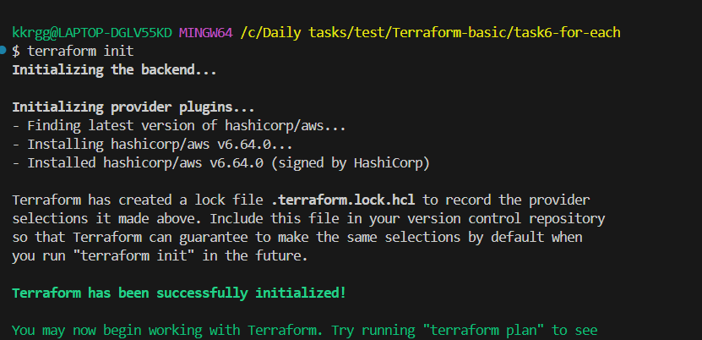

Step 9: Validate
terraform validate
Expected:
Success! The configuration is valid.
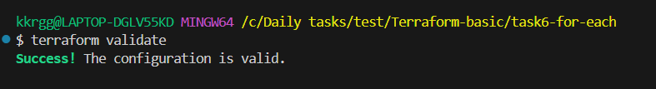

Step 10: Format
terraform fmt
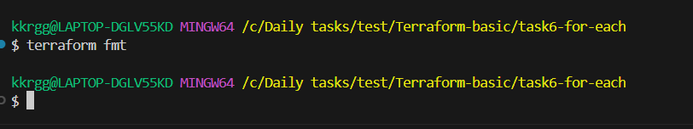

Step 11: Run Plan
terraform plan
You should see approximately:
Plan: 3 to add, 0 to change, 0 to destroy.
Why 3?
Because the map contains three entries:
web-server
app-server
dev-server

Step 12: Apply
terraform apply
Enter:
yes
Expected:
Apply complete! Resources: 3 added, 0 changed, 0 destroyed.
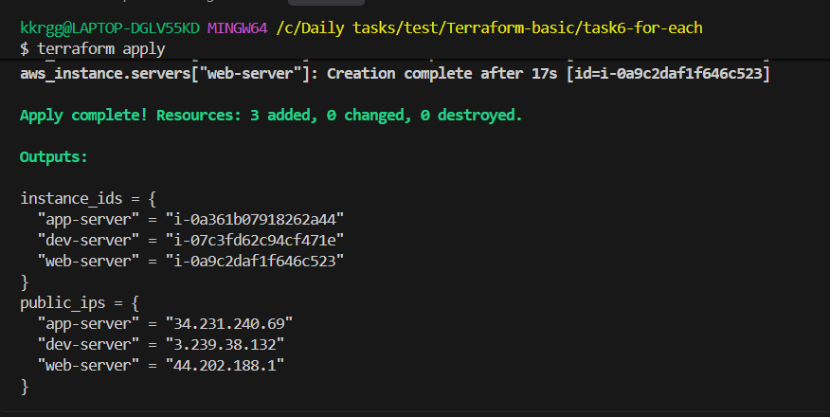

Step 13: Check Terraform outputs
Run:
terraform output
You should see something similar to:
instance_ids = {
"app-server" = "i-012345..."
"dev-server" = "i-023456..."
"web-server" = "i-034567..."
}

public_ips = {
"app-server" = "54.xx.xx.xx"
"dev-server" = "54.xx.xx.xx"
"web-server" = "54.xx.xx.xx"
}

Step 14: Check the Terraform state
Run:
terraform state list
You should see:
data.aws_subnets.default
data.aws_vpc.default
aws_instance.servers["app-server"]
aws_instance.servers["dev-server"]
aws_instance.servers["web-server"]
This is an important difference from count.
With for_each, Terraform identifies resources by their keys.

Step 15: Test changing one resource
Suppose we change:
instances = {
web-server = "t3.micro"
app-server = "t3.small"
dev-server = "t3.small"
}
Only app-server changed from:
t3.micro → t3.small
Run:
terraform plan
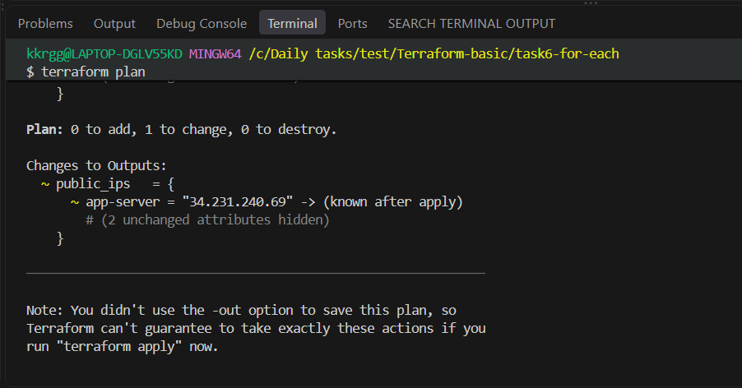
Terraform will identify the required change rather than treating the resources as simple numeric indexes.
This is one reason for_each is useful when resources have distinct identities.

Step 16: Add another server
Change:
instances = {
web-server = "t3.micro"
app-server = "t3.micro"
dev-server = "t3.small"
test-server = "t3.micro"
}
Run:
terraform plan
Terraform should show one additional resource:
aws_instance.servers["test-server"]
Then:
terraform apply
Only the new server needs to be created.

Step 17: Compare with count

count
resource "aws_instance" "server" {
count = 3

ami = var.ami
instance_type = "t3.micro"

tags = {
Name = "server-${count.index}"
}
}
Resources:
aws_instance.server[0]
aws_instance.server[1]
aws_instance.server[2]

for_each
resource "aws_instance" "servers" {
for_each = var.instances

ami = var.ami
instance_type = each.value

tags = {
Name = each.key
}
}
Resources:
aws_instance.servers["web-server"]
aws_instance.servers["app-server"]
aws_instance.servers["dev-server"]

Easy way to remember
count
↓
NUMBER
↓
0, 1, 2, 3...

for_each
↓
KEY/VALUE
↓
web-server
app-server
dev-server
7. Write a Terraform script using variables, terraform.tfvars, and output values.

Objective
Create an EC2 instance using:
- Terraform variables
- terraform.tfvars
- Variable references
- Output values
This task will help you understand how to avoid hardcoding values in Terraform configuration.

7.1 Create the project
Create a new folder:
mkdir task7-variables
cd task7-variables
Your structure will be:
task7-variables/
├── main.tf
├── variables.tf
├── terraform.tfvars
└── outputs.tf

7.2 Create variables.tf
Create:
variable "ami" {
description = "AMI ID for EC2"
type = string
}

variable "instance_type" {
description = "EC2 instance type"
type = string
default = "t3.micro"
}

variable "instance_name" {
description = "Name of EC2 instance"
type = string
}

What we created
Variable | Purpose
ami | AMI ID
instance_type | EC2 instance type
instance_name | EC2 Name tag
Notice that instance_type has a default value.

7.3 Create terraform.tfvars
Create:
ami = "YOUR_AMI_ID"

instance_type = "t3.micro"

instance_name = "task7-variable-server"
Replace:
YOUR_AMI_ID
with a valid Amazon Linux 2023 AMI in us-east-1.
For example, if your AMI is:
ami-xxxxxxxxxxxxxxxxx
then:
ami = "ami-xxxxxxxxxxxxxxxxx"

Why terraform.tfvars?
Instead of putting values directly inside main.tf:
ami = "ami-xxxxxxxx"
we use:
ami = var.ami
and provide the actual value in:
terraform.tfvars

7.4 Create main.tf
terraform {
required_providers {
aws = {
source = "hashicorp/aws"
version = "~> 6.0"
}
}
}

provider "aws" {
region = "us-east-1"
}

resource "aws_instance" "web" {
ami = var.ami
instance_type = var.instance_type

tags = {
Name = var.instance_name
}
}

Important part
ami = var.ami
Terraform gets the value from:
terraform.tfvars
And:
instance_type = var.instance_type
gets its value from:
terraform.tfvars

7.5 Create outputs.tf
output "instance_id" {
description = "EC2 instance ID"
value = aws_instance.web.id
}

output "public_ip" {
description = "EC2 public IP"
value = aws_instance.web.public_ip
}

output "instance_type" {
description = "EC2 instance type"
value = aws_instance.web.instance_type
}

output "instance_name" {
description = "EC2 instance name"
value = var.instance_name
}
Outputs allow us to easily retrieve important information after terraform apply.

7.6 Initialize Terraform
Run:
terraform init
Expected:
Terraform has been successfully initialized!
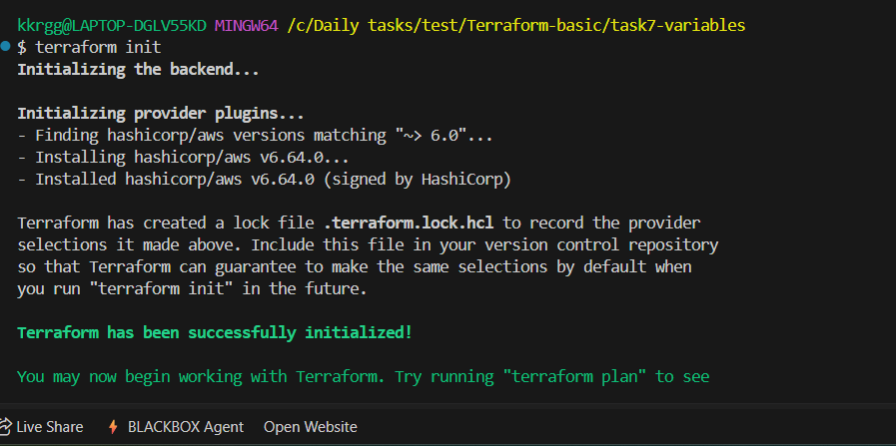

7.7 Validate
terraform validate
Expected:
Success! The configuration is valid.

7.8 Format
terraform fmt
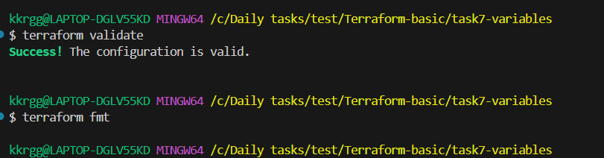

7.9 Run Plan
terraform plan
Terraform should show approximately:
Plan: 1 to add, 0 to change, 0 to destroy.
You should see something similar to:
+ resource "aws_instance" "web" {
+ ami = "ami-xxxxxxxx"
+ instance_type = "t3.micro"
+ tags = {
+ "Name" = "task7-variable-server"
}
}
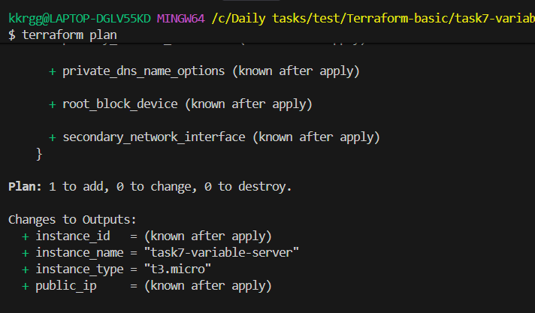

7.10 Apply
terraform apply
Enter:
yes
Expected:
Apply complete! Resources: 1 added, 0 changed, 0 destroyed.
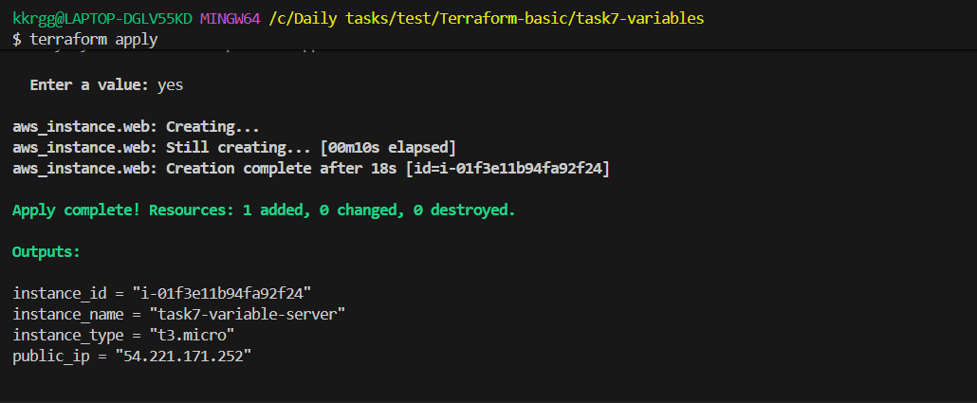

7.11 Check Outputs
Run:
terraform output
Expected:
instance_id = "i-xxxxxxxxxxxxxxxxx"
instance_name = "task7-variable-server"
instance_type = "t3.micro"
public_ip = "54.xx.xx.xx"
You can also check individual outputs:
terraform output instance_id
terraform output public_ip
8. Write a Terraform script using conditional expressions to create resources based on an environment variable

Objective
Create an EC2 instance only when the environment is prod.
You will practice:
- Terraform variables
- Conditional expressions
- count
- Environment-based infrastructure
- terraform.tfvars

Expected behavior
environment = "dev" → No EC2
environment = "prod" → 1 EC2
This is a very common Terraform interview and practical scenario.

8.1 Create the project
mkdir task8-conditional
cd task8-conditional
Files:
task8-conditional/
├── main.tf
├── variables.tf
├── terraform.tfvars
└── outputs.tf

8.2 Create variables.tf
variable "environment" {
description = "Deployment environment"
type = string

validation {
condition = contains(["dev", "prod"], var.environment)
error_message = "Environment must be either dev or prod."
}
}

variable "ami" {
description = "AMI ID for EC2"
type = string
}

variable "instance_type" {
description = "EC2 instance type"
type = string
default = "t3.micro"
}
The important variable is:
variable "environment"
It accepts only:
dev
prod

8.3 Create terraform.tfvars
Start with dev:
environment = "dev"
ami = "YOUR_AMI_ID"
instance_type = "t3.micro"
Replace:
YOUR_AMI_ID
with your valid Amazon Linux 2023 AMI for us-east-1.

8.4 Create main.tf
terraform {
required_providers {
aws = {
source = "hashicorp/aws"
version = "~> 6.0"
}
}
}

provider "aws" {
region = "us-east-1"
}

resource "aws_instance" "web" {
count = var.environment == "prod" ? 1 : 0

ami = var.ami
instance_type = var.instance_type

tags = {
Name = "task8-${var.environment}-server"
Environment = var.environment
}
}

🔑 Most important line
count = var.environment == "prod" ? 1 : 0
This is a conditional expression.
It means:
If environment == prod
↓
count = 1

Otherwise
↓
count = 0
So:
prod → EC2 created
dev → EC2 not created

8.5 Create outputs.tf
Because count is being used, we access the resource using [0].
output "environment" {
value = var.environment
}

output "instance_id" {
value = var.environment == "prod" ? aws_instance.web[0].id : "No EC2 created"
}

output "public_ip" {
value = var.environment == "prod" ? aws_instance.web[0].public_ip : "No EC2 created"
}

8.6 Initialize Terraform
terraform init
Expected:
Terraform has been successfully initialized!
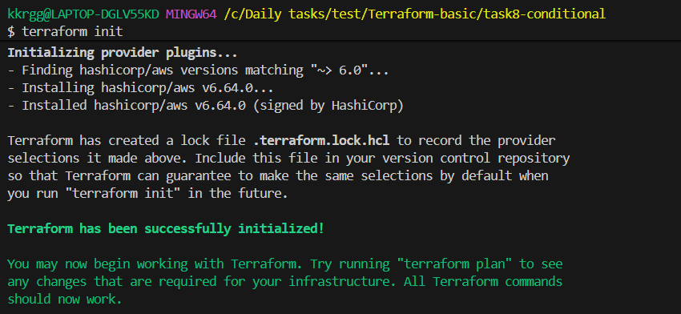

8.7 Validate
terraform validate
Expected:
Success! The configuration is valid.

8.8 Format
terraform fmt

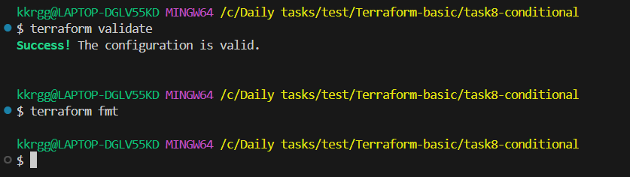

8.9 Test DEV environment
Currently terraform.tfvars contains:
environment = "dev"
Run:
terraform plan
You should see:
Plan: 0 to add, 0 to change, 0 to destroy.
Why?
Because:
var.environment == "prod"
is false.
Therefore:
count = 0
No EC2 will be created.
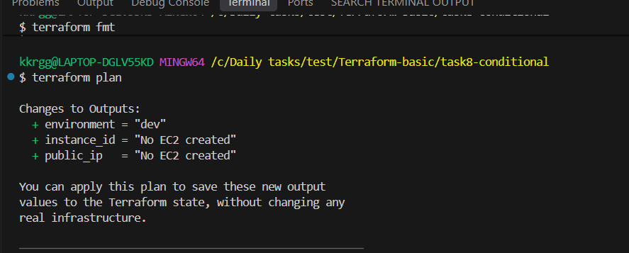

8.10 Apply DEV
terraform apply
Enter:
yes
Expected:
Apply complete! Resources: 0 added, 0 changed, 0 destroyed.
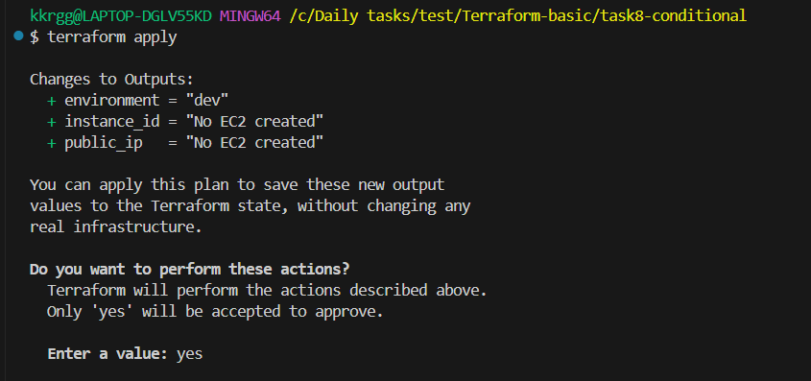

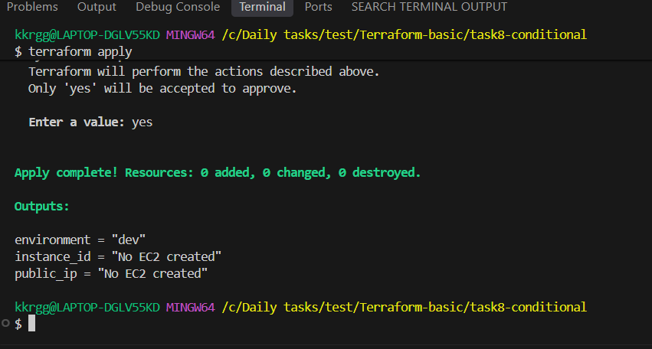
Then:
terraform output
Expected:
environment = "dev"
instance_id = "No EC2 created"
public_ip = "No EC2 created"

8.11 Now change to PROD
Edit terraform.tfvars.
Change:
environment = "dev"
to:
environment = "prod"
Final file:
environment = "prod"
ami = "YOUR_AMI_ID"
instance_type = "t3.micro"

8.12 Run Plan Again
terraform plan
Now Terraform should show:
Plan: 1 to add, 0 to change, 0 to destroy.
Because:
environment = prod
↓
condition = true
↓
count = 1
↓
EC2 created
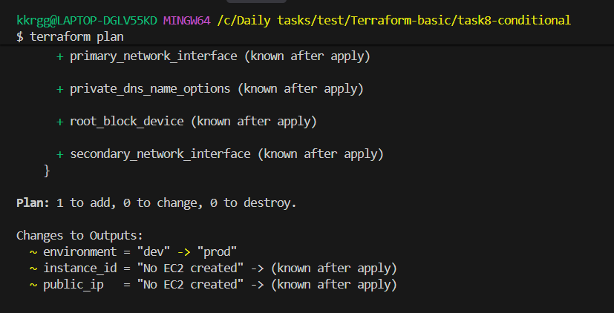

8.13 Apply PROD
terraform apply
Enter:
yes
Expected:
Apply complete! Resources: 1 added, 0 changed, 0 destroyed.
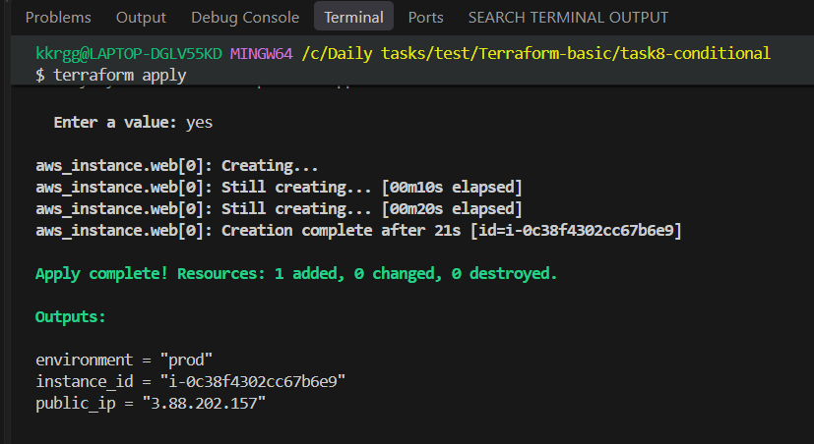
Check:
terraform output
You should get something similar to:
environment = "prod"
instance_id = "i-xxxxxxxxxxxxxxxxx"
public_ip = "xx.xx.xx.xx"

8.14 Check Terraform State
Run:
terraform state list
Expected:
aws_instance.web[0]
The [0] appears because we used:
count = 1
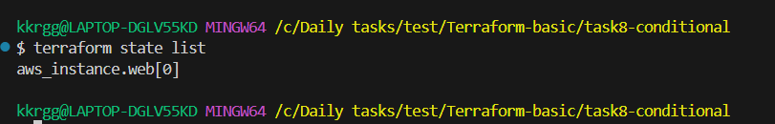

8.15 Test Switching Back to DEV
Change:
environment = "prod"
back to:
environment = "dev"
Run:
terraform plan
Terraform should show approximately:
Plan: 0 to add, 0 to change, 1 to destroy.
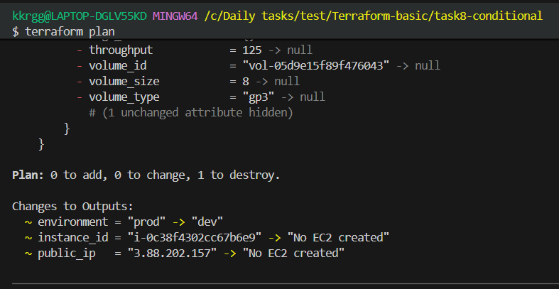

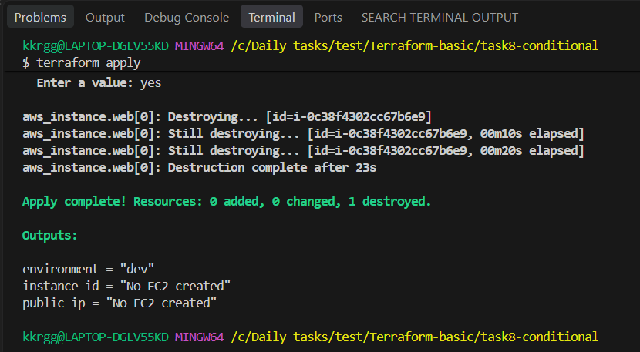

9. Explain the difference between count and for_each. When would you use each?

Count vs for_each
Feature | count | for_each
Input | Number | Map or set
Identifier | Index | Key
Example | count = 3 | for_each = var.servers
Access | count.index | each.key, each.value
Best for | Identical resources | Named/different resources
Resource address | [0], [1] | ["web"], ["app"]
count is best when I need a specific number of similar resources.
for_each is better when I need multiple resources identified by unique keys or when each resource can have different configuration.
Suppose you have:
servers = [
"web",
"app",
"db"
]
with count.
If you remove "app":
servers = [
"web",
"db"
]
Terraform's numeric indexes can cause resource identities to shift.
With:
for_each = {
web = "t3.micro"
app = "t3.micro"
db = "t3.micro"
}
removing:
app
targets:
aws_instance.server["app"]
The web and db keys remain stable.
This is one of the major reasons for_each is often preferred for collections of named resources.
10. Explain the difference between locals, variables, and outputs in Terraform.

10.1 Terraform Variables
A variable is an input to your Terraform configuration.
Think of it as:
Variable = value provided from outside the resource configuration
For example, conceptually:
instance_type = "t3.micro"
The same Terraform configuration can then be used with:
t3.micro
t3.small
t3.medium
without changing the main configuration.

Why use variables?
- Avoid hardcoding values
- Reuse Terraform configurations
- Make configurations configurable
- Support different environments
- Keep configuration flexible

Interview answer
Terraform variables are input values that allow us to customize and reuse Terraform configurations without hardcoding values.

10.2 Terraform Locals
Locals are values that Terraform calculates or defines inside the configuration for reuse.
Think of them as:
Locals = internal reusable values
For example, you might conceptually define:
environment = "prod"
project = "web"
and create a common naming value:
prod-web-server
Instead of repeatedly constructing that name throughout the configuration, you can use a local value.

Why use locals?
- Avoid repeating expressions
- Simplify complex expressions
- Create common naming conventions
- Organize configuration
- Make Terraform code easier to read

Important point
A local is not normally something the user supplies as an input.
It is calculated or defined inside Terraform.

Interview answer
Terraform locals are named internal values used to simplify expressions and avoid repeating the same values or calculations throughout a configuration.

10.3 Terraform Outputs
An output exposes information from Terraform after resources are created.
Think of it as:
Output = information Terraform gives back to you
Examples of information commonly exposed:
EC2 instance ID
Public IP
ALB DNS name
VPC ID
Subnet ID
RDS endpoint
For example:
terraform apply
↓
Terraform creates EC2
↓
Output
↓
Public IP
Outputs are especially useful when another module needs information from a child module.

10.4 Main Difference
Feature | Variable | Local | Output
Purpose | Input | Internal value | Output/result
Provided by user? | Usually yes | No | No
Used inside configuration? | Yes | Yes | Yes
Exposes information outside? | No | No | Yes
Reusability | High | High | High
Typical use | Instance type | Common naming | Instance IP

10.5 Simple Way to Remember
Remember this:
VARIABLE
↓
Input

LOCAL
↓
Internal calculation/value

RESOURCE
↓
Creates infrastructure

OUTPUT
↓
Returns information
Or simply:
Variable = Input
Local = Process/Reuse
Output = Result

10.6 Practical Example Concept
Imagine you're creating an application called shopping-app.
You might have:
Variable:
environment = prod
Then Terraform internally creates a local conceptually:
local.name = "shopping-app-prod"
The resource uses that name.
After creation, Terraform exposes:
Output:
instance_id
public_ip
So the flow is:
User
↓
Variable
↓
Local
↓
Resource
↓
Output

10.7 Variables vs Locals — Important Interview Difference
A common interview question is:

"Why not use variables instead of locals?"
Because they have different purposes.
Variables represent values that should be configurable from outside.
Locals represent values that are derived or reused internally.
For example:
Variable:
environment = prod
Then:
Local:
application_name = "myapp"
full_name = "myapp-prod"
environment can change depending on the deployment.
full_name is an internal value derived from the configuration.

10.8 Locals vs Outputs
Another common question:

"Can a local be used as an output?"
Yes.
Conceptually:
Local
↓
Output
A local can be used internally and then exposed through an output if needed.
But a local itself does not automatically appear after terraform apply.

11. What is the purpose of terraform plan and how is it different from terraform apply?

11.1 What is terraform plan?
terraform plan is used to preview the changes Terraform intends to make to your infrastructure.
It compares:
Terraform Configuration
+
Terraform State
+
Current Infrastructure
↓
Terraform Plan
↓
Changes to be made
It tells you whether Terraform will:
- Create resources
- Modify resources
- Destroy resources
- Make no changes

Example
Suppose your configuration requests an EC2 instance.
terraform plan might show:
Plan: 1 to add, 0 to change, 0 to destroy.
This means Terraform intends to create one resource.
Important: terraform plan normally does not make the infrastructure changes.

11.2 What is terraform apply?
terraform apply is used to actually make the changes described by Terraform.
Conceptually:
Terraform Configuration
↓
terraform apply
↓
Terraform Plan
↓
User confirmation
↓
Infrastructure changes
↓
Terraform State updated
For example:
Plan: 1 to add, 0 to change, 0 to destroy.
After approval, Terraform creates the resource.

11.3 Main Difference
terraform plan | terraform apply
Shows proposed changes | Executes changes
Primarily for preview | Used to provision/update infrastructure
Does not normally modify infrastructure | Modifies infrastructure
Useful for review | Useful for deployment
Helps detect unexpected changes | Performs the approved changes

11.4 Why is terraform plan important?
Imagine you changed a Terraform configuration but accidentally introduced something that would destroy an important resource.
Without reviewing the plan, you might apply the change immediately.
The plan could show:
Plan: 0 to add, 1 to change, 3 to destroy.
That gives you an opportunity to stop and investigate.

DevOps practice
A common workflow is:
Code change
↓
terraform fmt
↓
terraform validate
↓
terraform plan
↓
Review
↓
terraform apply
In CI/CD, the plan is often reviewed or approved before the apply stage.

11.5 Terraform Plan Symbols
When reading a plan, you'll commonly see:

+ Create
+ aws_instance.web
Terraform plans to create the resource.

~ Change
~ aws_instance.web
Terraform plans to modify the existing resource.

- Destroy
- aws_instance.web
Terraform plans to remove the resource.

-/+ Destroy and recreate
This is important.
It means Terraform cannot simply modify the existing resource and instead needs to:
Destroy old resource
↓
Create new resource
This can happen when changing certain attributes that require replacement.

11.6 What happens to the state?
After a successful terraform apply, Terraform updates the state file with information about the infrastructure.
Conceptually:
Configuration
↓
Apply
↓
AWS Infrastructure
↓
Terraform State
The state helps Terraform understand:
"What resources do I currently manage?"
On the next plan, Terraform can compare the desired configuration with the state/current infrastructure and determine what needs to change.

11.7 Does terraform plan guarantee that apply will succeed?
No.
The plan is a preview.
Things can change between planning and applying.
For example:
- AWS permissions may change
- A resource may be manually deleted
- AWS quotas may be reached
- Another person may modify infrastructure
- Network/API problems may occur
Therefore:
A successful plan does not guarantee a successful apply.

12. Explain the Terraform resource lifecycle and the use of create_before_destroy.
Terraform lifecycle rules control how Terraform creates, updates, and destroys resources.
The lifecycle block is used inside a Terraform resource to change Terraform's normal behavior.
The main lifecycle arguments are:
- create_before_destroy
- prevent_destroy
- ignore_changes
- replace_triggered_by

12.1 create_before_destroy
Normally, when a resource must be replaced, Terraform may do:
Destroy old resource
↓
Create new resource
With:
lifecycle {
create_before_destroy = true
}
Terraform attempts:
Create new resource
↓
Destroy old resource

Why is this useful?
It can reduce downtime.
For example, suppose an application server needs to be replaced.
Without it:
Old server
↓
Destroyed
↓
New server created
There may be downtime.
With create_before_destroy:
Old server ──────────────┐
│
New server created │
↓ │
New server available │
↓ │
Old server destroyed ◄───┘

Interview answer
"create_before_destroy tells Terraform to create the replacement resource before destroying the existing resource, which can help reduce downtime."

12.2 prevent_destroy
prevent_destroy protects an important resource from being destroyed by Terraform.
Conceptually:
lifecycle {
prevent_destroy = true
}
If Terraform determines that the resource needs to be destroyed, Terraform will stop and produce an error instead of destroying it.

Typical use cases
This can be useful for resources such as:
- Production databases
- Important S3 buckets
- Critical infrastructure

Example scenario
Suppose you have a production database.
Someone changes the Terraform configuration in a way that would cause the database to be destroyed.
With prevent_destroy:
Terraform plan
↓
Database destruction detected
↓
prevent_destroy
↓
Terraform blocks the operation

Important point
prevent_destroy is not a replacement for backups.
It protects against Terraform destruction, but you should still have proper backup and recovery strategies.

Interview answer
"prevent_destroy prevents Terraform from destroying a resource accidentally and is useful for protecting critical resources such as production databases."

12.3 ignore_changes
ignore_changes tells Terraform to ignore changes to specific resource attributes.
This is useful when some attributes are managed outside Terraform.
For example:
Terraform
↓
Manages EC2

Another system
↓
Changes a specific tag
Terraform might normally detect that difference.
With ignore_changes, Terraform can be instructed to ignore that particular attribute.
Conceptually:
lifecycle {
ignore_changes = [
tags
]
}

Why use it?
Sometimes infrastructure is managed by multiple systems.
For example:
Terraform
+
AWS Auto Scaling
+
External automation
If another system changes an attribute that Terraform should not continuously overwrite, ignore_changes can be useful.

Important warning
Do not use ignore_changes simply to hide unexpected differences.
It can hide real configuration drift.

Interview answer
"ignore_changes tells Terraform to ignore changes to specified resource attributes, which is useful when those attributes are intentionally managed outside Terraform."

12.4 replace_triggered_by
replace_triggered_by tells Terraform to replace a resource when another resource or attribute changes.
Conceptually:
Resource A changes
↓
replace_triggered_by
↓
Resource B is replaced
This is useful when two resources have a dependency where a change in one should cause replacement of another.

Interview answer
"replace_triggered_by allows us to trigger replacement of a resource when a specified resource or resource attribute changes."

12.5 Comparison
Lifecycle rule | Purpose
create_before_destroy | Create replacement before destroying old resource
prevent_destroy | Prevent Terraform from destroying resource
ignore_changes | Ignore selected attribute changes
replace_triggered_by | Replace resource when another resource/attribute changes
13. What is depends_on in Terraform? Give a practical example

13.1 What is depends_on?
depends_on is a Terraform meta-argument used to explicitly tell Terraform:
"Create this resource only after that resource has been created."
It is used to define an explicit dependency between resources.

13.2 Why do we need depends_on?
Terraform automatically understands many dependencies.
For example, if one resource directly references another:
Resource A
↓
Resource B
Terraform knows that B depends on A.
But sometimes there is a dependency that Terraform cannot determine from the configuration.
In that situation, we can use:
depends_on = [
aws_some_resource.example
]

13.3 Simple Example
Imagine:
VPC
↓
Application
The application logically depends on the VPC.
If Terraform cannot determine that relationship automatically, we can explicitly tell Terraform:
Application
↓
depends_on
↓
VPC
Terraform will create the VPC first.
depends_on = explicitly tell Terraform which resource must be completed first.

14. What is the difference between implicit and explicit dependencies?

14.1 What is a Dependency?
A dependency means:
One Terraform resource needs another resource to exist or be completed first.
For example:
VPC
↓
Subnet
↓
EC2
Terraform needs to understand this order so that resources are created correctly.
Terraform has two main types of dependencies:
- Implicit dependency
- Explicit dependency

14.2 Implicit Dependency
An implicit dependency is a dependency Terraform automatically understands from a resource reference.
For example, conceptually:
EC2
↓
references
↓
Security Group
If the EC2 configuration uses the Security Group's ID, Terraform sees that relationship.
Terraform automatically understands:
Security Group
↓
EC2
So you don't need to manually tell Terraform about the dependency.

Key point
Terraform creates an implicit dependency when one resource references an attribute of another resource.

14.3 Example
Imagine:
Security Group
↓
Security Group ID
↓
EC2
The EC2 needs the Security Group ID.
Terraform sees:
EC2 → Security Group ID
and builds the dependency graph:
Security Group
↓
EC2
Therefore:
Security Group
will be created before:
EC2

14.4 Explicit Dependency
An explicit dependency is when you manually tell Terraform about a dependency using:
depends_on
Conceptually:
Resource B
↓
depends_on
↓
Resource A
Terraform then knows:
A must be completed before B

14.5 Why Would We Need Explicit Dependencies?
Sometimes there is a logical dependency that Terraform cannot see from resource references.
For example:
IAM configuration
↓
Application
The application might logically require the IAM configuration to be completed first, but if there is no direct attribute reference connecting them, Terraform may not automatically know about the dependency.
In such a case:
depends_on
can explicitly communicate the relationship.

14.6 Main Difference
Implicit Dependency | Explicit Dependency
Terraform detects automatically | Developer defines it
Created through resource references | Created using depends_on
Usually preferred | Used when necessary
Less configuration | Additional configuration
Terraform understands relationship naturally | Developer tells Terraform the relationship

15. Explain Terraform modules. What are root and child modules?

15.1 What is a Terraform Module?
A Terraform module is a collection of Terraform configuration files that are grouped together and can be reused.
Instead of putting everything into one large Terraform configuration, we can organize infrastructure into reusable modules.
For example:
VPC Module
EC2 Module
S3 Module
RDS Module
Then the main Terraform configuration can use those modules.

15.2 Why Do We Use Modules?
Modules help with:
- Reusability
- Organization
- Consistency
- Reducing duplicate code
- Managing large infrastructure
- Standardizing infrastructure
For example, suppose you need EC2 instances for:
Development
QA
Production
Instead of writing the same EC2 configuration three times, you can create one reusable EC2 module.
EC2 Module
/ | \
/ | \
Dev QA Prod

15.3 What is the Root Module?
The root module is the Terraform configuration from which you run Terraform commands.
For example, when you run:
terraform plan
terraform apply
from a directory, that directory represents the root module.
Conceptually:
Root Module
│
├── main.tf
├── variables.tf
├── outputs.tf
└── terraform.tfvars
The root module is responsible for calling and configuring child modules.

15.4 What is a Child Module?
A child module is a reusable Terraform module called by another module.
For example:
Root Module
│
├── VPC Module
├── EC2 Module
└── S3 Module
Each child module can contain its own:
main.tf
variables.tf
outputs.tf

15.5 Root Module vs Child Module
Root Module | Child Module
Where Terraform commands are normally executed | Called by another module
Main entry point | Reusable component
Calls child modules | Provides infrastructure functionality
Provides module inputs | Receives variables
Consumes module outputs | Exposes outputs
Represents the overall deployment | Represents a specific component
16. How do you pass variables from a root module to a child module?
When a root module calls a child module, the root module can pass values to the child module using input variables.
The flow is:
Root Module
│
│ input values
↓
Child Module
│
↓
Resources
For example, the root module might provide:
environment = "prod"
instance_type = "t3.micro"
to an EC2 child module.

How Does It Work Conceptually?
There are three important parts.

1. Child module declares a variable
The child module says:
"I need an instance type."
Child Module
↓
variable: instance_type

2. Root module provides the value
The root module says:
instance_type = "t3.micro"

3. Child module uses that variable
The child module uses:
var.instance_type
So the complete flow is:
Root Module
│
│ "t3.micro"
↓
Child Module Variable
│
│ var.instance_type
↓
EC2 Resource

Imagine a reusable EC2 module.

The child module needs:
AMI
Instance Type
Environment
The root module can provide:
AMI → Amazon Linux AMI
Instance Type → t3.micro
Environment → dev
The same child module can then be reused for production:
AMI → Amazon Linux AMI
Instance Type → t3.small
Environment → prod
The child module doesn't need to be rewritten.

17. How do you pass output values from a child module to the root module?

Objective
Understand how a child module returns information to the root module using Terraform output values.

17.1 What does Child → Root mean?
When a child module creates infrastructure, the root module may need information about that infrastructure.
For example, a child module creates an EC2 instance and produces:
- Instance ID
- Public IP
- Private IP
The child module can expose these values using outputs.
The root module can then access those outputs.

17.2 Flow
The basic flow is:
Child Resource → Child Output → Root Module
For example:
EC2 instance → child output for instance ID → root module receives instance ID
The root module can then:
- Display the value
- Use it in another resource
- Pass it to another child module
- Expose it through a root-level output

17.3 Why do we use outputs?
Outputs provide a controlled way for a child module to expose useful information.
They help with:
- Module communication
- Reusability
- Encapsulation
- Avoiding direct dependency on the child's internal resources
The root module doesn't need to know every detail about how the child module creates its resources.

18. What is the difference between local modules and remote modules?

18.1 What is a Local Module?
A local module is a Terraform module stored on your local machine or inside the same project/repository.
For example, you might organize your Terraform project like:
Root module
- VPC configuration
- EC2 configuration
- S3 configuration
and keep reusable modules in folders such as:
- modules/vpc
- modules/ec2
- modules/s3
The root module can call these local modules.

18.2 Why use Local Modules?
Local modules are useful when:
- You are developing your own modules.
- The module is specific to your organization/project.
- You want to test a module locally.
- You want all Terraform code in the same repository.
- You need full control over the module code.

18.3 What is a Remote Module?
A remote module is a Terraform module stored outside your local project.
Common locations include:
- Terraform Registry
- GitHub
- Git repositories
- Object storage
- Other supported remote sources
Instead of maintaining the module yourself locally, Terraform retrieves the module from its remote source.

18.4 Why use Remote Modules?
Remote modules are useful when:
- A module is shared across multiple projects.
- Your organization maintains a centralized module repository.
- You want to reuse an existing community module.
- You want standardized infrastructure configurations.
- You want to version and distribute modules centrally.

18.5 Local vs Remote Modules
Feature | Local Module | Remote Module
Location | Local project/filesystem | External source
Ownership | Usually your project/team | Can be your team or third party
Internet required | Usually no | Usually when downloading/updating
Reusability | Good | Very good
Centralized sharing | Limited | Easy
Common use | Development/project-specific modules | Organization-wide/shared modules
A local module is stored on the local filesystem, usually within the Terraform project or repository. A remote module is stored at an external source such as Terraform Registry or Git, and Terraform retrieves it for use. Local modules are useful for project-specific development, while remote modules are useful for sharing and standardizing reusable infrastructure across multiple projects.

19. How do you manage different environments such as Dev, QA, and Production using Terraform?
We can manage multiple environments using separate configurations or directories, workspaces, and reusable Terraform modules. A common approach is to create reusable modules and maintain separate environment configurations and state for Dev, QA, and Prod. Each environment can provide different values such as instance size, scaling, networking, and other environment-specific settings while reusing the same infrastructure modules.
20. Explain the purpose of .terraform.lock.hcl?
.terraform.lock.hcl is Terraform's dependency lock file.
It records the provider versions and checksums that Terraform has selected for a configuration.
For example, if your configuration uses the AWS provider, Terraform may select a specific version such as:
AWS provider → v6.x.x
The lock file records that selection so future Terraform runs can use the same approved provider version.

